EXPERIMENT NO.8 (SAILOR BOAT DATABASE (DDL,DML,DQL, Subquery, Joins, Set operations)

AIM:

* Create sailors, boats, and reserves. (foreign key)
* Insert 5 values each table.
* Display all records.
* Find the names and ages of all sailors.
* Find all sailors with ratings above 8.
* Find sailors name with rating above 7 & age above 25.
* Display all the names & colours of the boats.
* Find all the boats with Red colours.
* Find the names of sailors' who have reserved boat number 103.
* Find the sids of sailors who have reserved blue boat
* Find the names of sailors' who have reserved Red boat.
* Find the colours of boats reserved by some name (provide any name in table).
* Find the names of the sailors who have reserved at least one boat.
* Find the names of the sailors who have reserved two different boats.
* Find the names of sailors who have reserved a Red or a Green boat. (union)
* Find the names of sailors who have reserved both a Red and a Green boat.
* Find the names of sailors who have reserved boat 103. (nested query)
* Find the names of sailors who have reserved red boat. (nq)
* Find the names of sailors who have not reserved red boat. (nq)
* Find the names of sailors who have reserved boat number 103. (exists)
* Find sailors whose rating is better than some sailors called name.
* Find sailors whose rating is better than every sailor' called name.
* Find the sailors with highest rating.
* Find the average age of all sailors.
* Find the average age of sailors with a rating of 10.
* Count the number of sailors.
* Count the number of different sailor ratings.
* Find the name and age of the oldest sailor.
* Find the names of the sailors who are older than the oldest sailor with a rating of 10.
* Find the age of youngest sailor for each rating level.
* Find the age of the youngest sailor who is eligible to vote (i.e., is at least 18 years old) for each rating level with at least two such sailors.
* For each red boat, find the number of reservations for this boat.
* Find all sailors name according to names.
* Find all sailors details according to rating.
* Find all sailors details according to rating (highest first) if ratings are same then according to age (youngest first).

SOLUTION:

**Components:**

Subquery: A subquery is also called an inner query or inner select, while the statement containing a subquery is also called an outer query or outer select.

Joins: A join is an SQL operation performed to establish a connection between two or more database tables based on matching columns, thereby creating a relationship between the tables.

Set operations: Set Operations in SQL eliminate duplicate tuples and can be applied only to the relations which are union compatible. Set Operations available in SQL are :

1. Set Union

2. Set Intersection

3. Set Difference

CREATE SCHEMA Sailors;  
CREATE TABLE sailors(sid integer, sname varchar(30),rating integer, age real,primary key(sid));  
CREATE TABLE boats(bid integer, bname varchar(30),color varchar(20),PRIMARY KEY (bid));  
CREATE TABLE reserves(sid integer, bid integer, day date,foreign key(sid) references sailors(sid),foreign key(bid)references boats(bid));  
  
desc sailors;  
desc boats;  
desc reserves;  
  
Insert into sailors values(22,'Dustin',7,45.0),(29,'Brutus',1,33.0),(31,'Lubber',8,55.5),(32,'Andy',8,25.5),(58,'Rusty',10,35.0);  
insert into boats values(101,'Interlake','blue'),(102,'Interlake','red'),(103,'Clipper','green'),(104,'Marine','red');  
insert into reserves values(22,101,'98-10-10'),(22,102,'98-10-10'),(22,103,'98-8-10'),(22,104,'98-7-10'),(31,102,'98-10-11');  
select * from boats;  
select * from reserves;  
  
select sname,age from sailors;  
select * from sailors where rating>8;  
select sname from sailors where rating>7 and age>25;  
select bname,color from boats;  
select * from boats where color='red';

CREATE TABLE s1(sid integer, sname varchar(30),rating integer, age real,primary key(sid));  
CREATE TABLE s2(sid integer, sname varchar(30),rating integer, age real,primary key(sid));  
Insert into s1 values(22,'Dustin',7,45.0),(31,'Lubber',8,55.5),(58,'Rusty',10,35.0);  
Insert into s2 values(28,'Yuppy',9,35.0),(31,'Lubber',8,55.5),(44,'Guppy',5,35.0),(58,'Rusty',10,35.0);  
select * from s1 cross join s2;  
#inner join  
select s1.sid,s1.sname,s2.age from s1 inner join s2 on s1.sid=s2.sid;  
  
#left join  
select s1.sname,s1.rating,s2.age from s1 left join s2 on s1.sid=s2.sid;  
  
#right join  
select s1.sname,s1.rating,s2.age from s1 right join s2 on s1.sid=s2.sid;  
  
#full outer join  
select s1.sname,s1.rating,s2.age from s1 left join s2 on s1.sid=s2.sid union all select s1.sname,s1.rating,s2.age from s1 right join s2 on s1.sid=s2.sid;  
  
select s.sname from sailors s, reserves r where s.sid=r.sid and r.bid=103;  
select s.sid from sailors s,reserves r,boats b where s.sid=r.sid and r.bid= b.bid and b.color="blue";  
select s.sname from sailors s,reserves r,boats b where s.sid=r.sid and r.bid=b.bid and b.color="red";  
select b.color from sailors s,reserves r,boats b where s.sid=r.sid and r.bid=b.bid and s.sname='Dustin';  
select distinct s.sname from  sailors s,reserves r where s.sid=r.sid ;  
select s.sname from sailors s ,reserves r,boats b where s.sid = r.sid and r.bid=b.bid and b.color="red"  
UNION  
select s.sname from sailors s ,reserves r,boats b where s.sid = r.sid and r.bid=b.bid and b.color="green";  
  
  
  
select s.sname from sailors s where s.sid IN ( SELECT r.sid FROM reserves r WHERE r.bid = 103 ) ;  
select s.sname from sailors s where s.sid IN (select r.sid from reserves r where r.bid in (select b.bid from boats b where b.color='red'));  
  
  
select s.sname from sailors s where s.sid not IN (select r.sid from reserves r where r.bid in (select b.bid from boats b where b.color='red'));  
select s.sid from sailors s where exists(select * from reserves r where r.bid=103 and r.sid=s.sid);  
select s.sid from sailors s where  s.rating > ANY (SELECT s.rating FROM sailors s WHERE s.sname = 'Dustin' );  
select s.sid from sailors s where  s.rating >any (SELECT s.rating FROM sailors s WHERE s.sname = 'Andy'  );  
select s.sid from sailors s where s.rating >= all (select s.rating from sailors s );  
select avg(age) from sailors;  
select avg(s.age) from sailors s where s.rating = 10;  
select count(sid) from sailors;  
select count(distinct rating) from sailors;  
select s.sname,s.age from sailors s where s.age= (select max(s.age) from sailors s);  
select s.sname from sailors s where s.age>all(select max(s.age) from sailors s where s.rating=10 );  
SELECT s.rating, min(s.age) FROM sailors s GROUP BY s.rating;  
SELECT s.rating, min(s.age) FROM sailors s WHERE s.age >= 18 GROUP BY s.rating HAVING count(*) > 1;  
  
SELECT B.bid,count(*) FROM boats B,reserves R WHERE R.bid=B.bid AND B.color='red' GROUP BY B.bid;  
select s.sname from sailors s order by s.sname;  
select * from sailors s order by s.rating;  
select * from sailors s order by s.rating desc,age asc ;

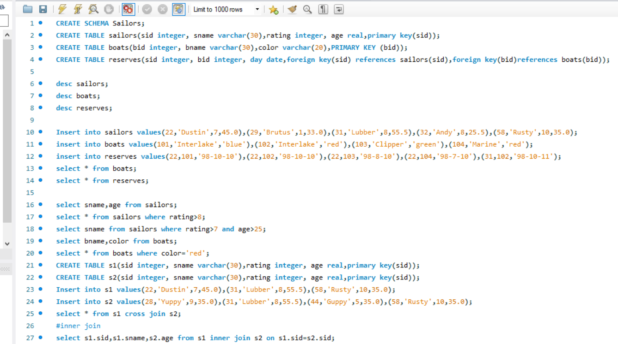

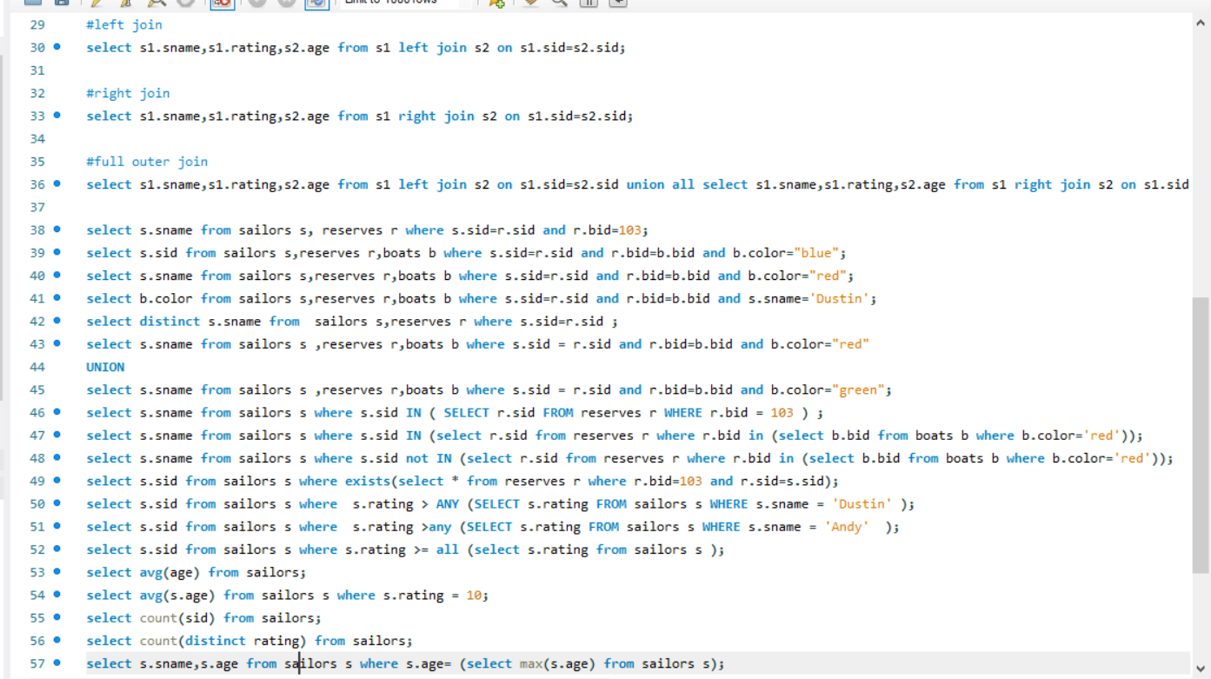

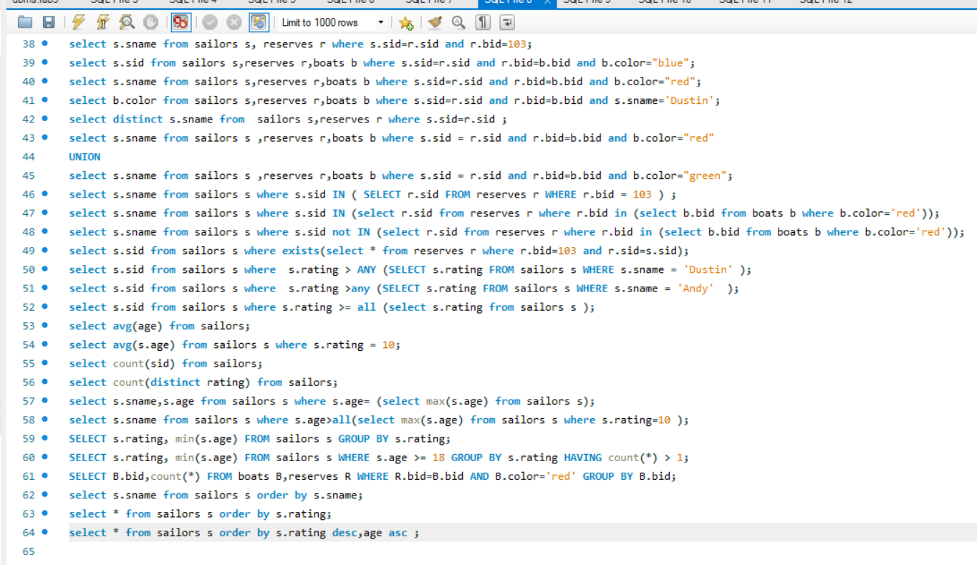

OUTPUT:



    
    
    

